# Page 3 – Dashboard

Inquiry/Payment is always enabled.

Qualification process is only enabled when the client has paid for the process.

The 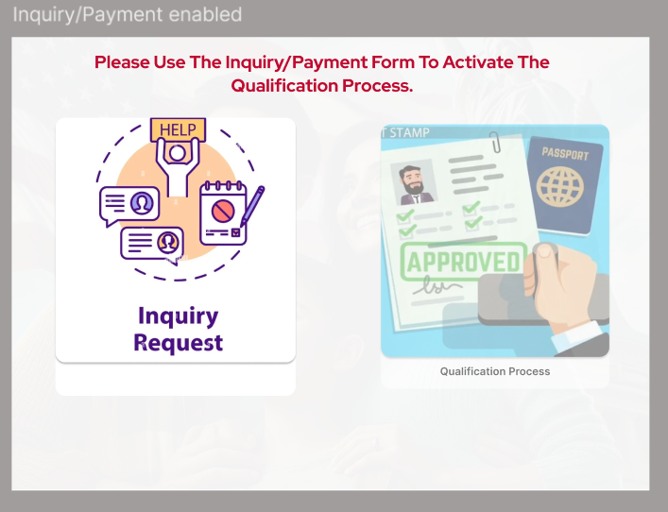

# Inquiry/Payment Form

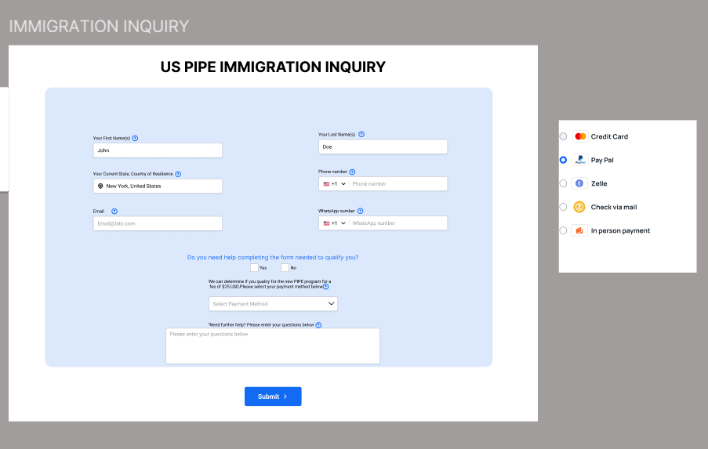

The form should be smart. If we already verify an email, ask for the cell. If we already verify a cell, ask for an email. But again, many of these clients don’t have emails.

If they select Yes for needing help to complete the qualification form, we add SystemData.CostofAssistance to the SystemData.CostofQualification.

For Phase I, we are only going to give links to Stripe and PayPal if they select these payment methods. We get those links from the SystemData table.

We display a corresponding help text that gives them instructions to pay via Zelle, By Mailing a Check or coming into the office. We’ll can keep those messages in either the SystemData table or the Screen table.

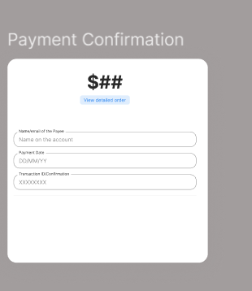

Once they’ve entered their TransactionID/Confirmation #, we’ll do basic verification, and if the verification passes, we enable the Qualification screen. For individuals who paid for help filling out the form, we also enable a link for Calendly where they book their appointment with a person that’s going to help them.